Monroe Community College

Elevation Nation

Maxim Karasev, Piotr Cetner, and Omar Nadeem

May 22nd, 2023

# 1. Executive Summary:

This executive summary provides an overview of our independent project focused on the development of a Vertical Take-Off and Landing (VTOL) Unmanned Aerial Vehicle (UAV). The project aimed to explore the advancements in VTOL technology at a hobbyist level and create a functioning prototype to be upscaled by future students.

Traditional aircraft designs, such as helicopters, planes, and multirotors, have inherent limitations in terms of maneuverability, adaptability, and efficiency. VTOL UAVs combine the vertical take-off and landing capabilities of helicopters and multirotors with the speed and efficiency of fixed-wing aircraft. We decided that a VTOL UAV was an optimal solution to overcome the limitations of traditional aircraft due to its unique combination of capabilities. By utilizing vertical take-off and landing, the VTOL can access confined or hard-to-reach areas, making it suitable for a wide range of applications where a plane simply could not. Furthermore, VTOL aircraft can take off from such an area and then transition to a forward flight mode, allowing it to regain all the traditional advantages a fixed-wing aircraft would have.

Throughout the project, we meticulously analyzed and iteratively improved the design of our VTOL. We encountered and successfully resolved several challenges, such as power distribution issues, control mixing and PID tuning, landing gear and battery mount optimization, and motor and ESC selection. These endeavors involved extensive troubleshooting, redesigning of components, and iterating 3D parts with new revisions. This meticulous approach to design analysis led to significant improvements. Notably, we fine-tuned the PID controls for each axis, ensuring stable and controlled vertical flight. The redesign of the landing gear and battery mount significantly improved rigidity, while the use of LW-HT-PLA material decreased the weight of the craft without sacrificing too much strength.

While we have achieved notable milestones in our project, such as winning the first-place prize in STEM at our college's scholar's day, there are still areas for further development. For example, we are exploring the integration of a DJI FPV camera using the QLiteOSD kit to enhance flight capabilities. The upcoming delivery of new motors will also enable us to continue our testing, expanding it into forward flight.

In conclusion, our independent project has proven to be a valuable exploration of VTOL technology. By combining vertical take-off and landing capabilities with adaptable flight modes, we have created a unique aircraft. By carefully analyzing our design, troubleshooting, and seeking continuous improvement, we have made considerable progress toward our objectives. Our ongoing dedication to the project's advancement ensures that we will continue refining and expanding the capabilities of our VTOL as time passes.

# 2. Table of Contents

Contents

1. Executive Summary: 1

2. Table of Contents 2

3. Design Evolution 3

4. UAV Operation 7

5. Electronics and Software 8

6. Fabrication Methods 13

7. Design Analysis: 17

8. Team and Technical Analysis 18

# 3. Design Evolution

Our team embarked on an extensive design process to develop our VTOL. This section highlights the key stages and decisions we made throughout the design stage, providing insights into our design`\ process and the rationale behind our choices. We utilized a combination of CAD modeled parts, circuit schematics, and software code/flowcharts to outline our design journey.

* Initial Ideas and Conceptualization:

The design process began with brainstorming sessions where we explored various concepts and potential solutions. We were motivated by our fascination with VTOL technology and its advantages over traditional aircraft designs. After seeing a VTOL design by Tom Staton, an aerospace engineer, seamlessly transition between vertical take-off and landing and forward flight, we knew we had to build a VTOL ourselves. Initial sketches and concept diagrams captured our early ideas and formed the foundation of our design.

Figure 1: Initial Sketch

Figure 2: Initial Assembly

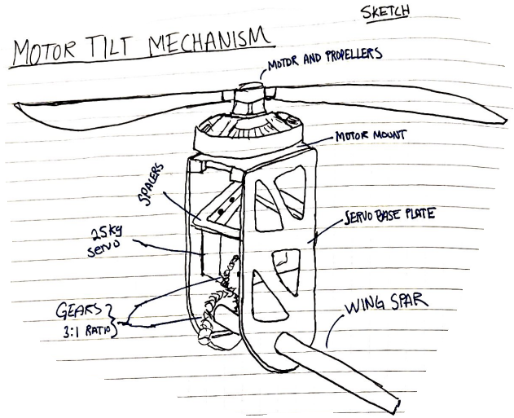

Figure 3: Motor Tilt Mechanism

* Additive Manufacturing for Rapid Prototyping and Iteration:

Recognizing the potential of 3D printing, we leveraged this technology to fabricate various components of our VTOL. Although we are all mechanical engineering students, and could have manufactured our parts via subtractive manufacturing, we intentionally chose not to do this. The ability to create complex geometries and intricate designs through 3D printing simplifies the design process immensely, as there is near no thought regarding how easy a part is to machine. Additionally, 3d printing reduces the amount of active labor required to prototype so many parts. Traditionally, creating a part for the first time requires someone to be actively working and monitoring any tooling, and this holds true for all future revisions of that part as well. Additive manufacturing allowed us to design a part, press print, go to class, and come back to the finished part in a few hours. If a part ever breaks or needs to be redesigned, then the same process holds true: press print, and come back a few hours later to a finished part. The time savings of additive manufacturing in prototyping is incredible; had we not had access to 3d printers, there is no way we would have been able to proceed at the rate we have been.

* System Architecture and Integration:

Once we had a rough idea of what we wanted to design, we focused on developing a robust system architecture. We identified the critical components, such as the flight controller, motor system, power distribution, and control system, and carefully planned their integration. SolidWorks images and circuit schematics were instrumental in visualizing and refining the system architecture, ensuring proper component placement and interconnectivity.

* Control Mixing and PID Tuning:

Achieving stable flight control was a crucial aspect of our design. We dedicated a considerable amount of time to control mixing and PID tuning, iteratively adjusting the control parameters to maximize performance. None of us had ever had to do any sort of PID tuning, so this was quite a learning experience for us. Software code and flowcharts were used to outline our control algorithms and visualize the flow of information between the inertial measurement unit (IMU) and the flight controller. This process allowed us to refine the control response and ensure stable flight characteristics.

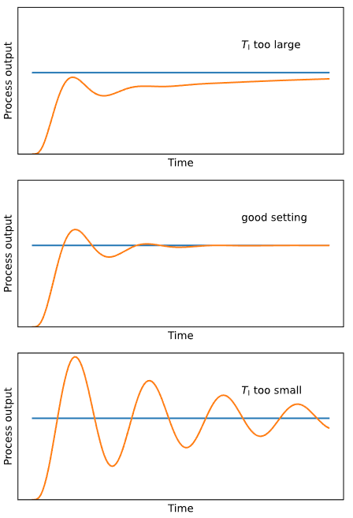Proportional Integral Derivative

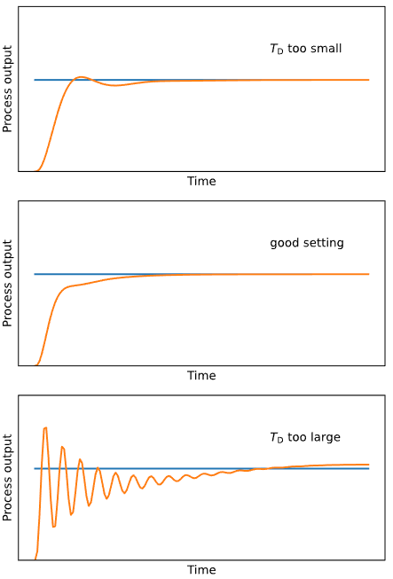

Figure 4: PID Graphs

1. Proportional Gain (KP): The proportional gain determines the strength of the corrective action applied by the controller. Increasing KP enhances system responsiveness but can introduce overshooting and oscillations, while decreasing KP reduces responsiveness and can result in sluggish behavior. The Proportional Range (XP) limits the range of error values where the proportional action is effective. A wider XP allows proportional control over a larger range, potentially leading to overshooting or instability, while a narrower XP reduces the influence of proportional control and responsiveness near the setpoint.
2. Integration Time (TI): The integration time determines the rate at which the integral action corrects for steady-state errors. Increasing TI strengthens the integral action and reduces steady-state errors, but excessively high values can introduce overshoot and instability.
3. Derivative Time (TD): The derivative time influences the controller's response to the rate of change of the error. Higher TD values introduce more damping, helping to prevent overshooting and oscillations, but extremely high values can introduce response delays and instability.

* Component Optimization and Redesign:

Throughout the design evolution, we encountered challenges and identified areas for improvement. The landing gear and battery mount, for instance, initially relied on zip ties, but we quickly realized the need for a more rigid and secure solution. We iterated on the design, utilizing ABS plastic parts clamped the components onto carbon fiber square rods with M5 bolts. This optimization significantly enhanced the structural integrity of the UAV. We documented these design iterations in our notebooks and captured revised sketches to track the progress.

Figure 5: Landing Gear Redesign

* Material Selection and Testing:

In pursuit of lightweight yet durable components, we explored various materials. Our experimentation led us to LW-HT-PLA, which exhibited superior flexibility and improved impact resistance compared to regular PLA. We tested the material by conducting destructive testing, observing how our wing segments broke when thrown at the ground. These observations allowed us to improve each successive revision of the wings and influenced the final material selection.

Figure 6: Broken Wing

* Future Enhancements:

While our design has reached an advanced stage, we continue to explore opportunities for further development. Integration of a DJI FPV camera using the QLiteOSD kit is one area we are actively working on. Additionally, the impending arrival of new motors will open avenues for testing and refining the forward flight capabilities of our VTOL. Our ongoing commitment to continuous improvement ensures that our design will evolve and adapt as we strive for enhanced performance and functionality.

The design evolution of our VTOL UAV highlights our iterative and detail-oriented approach. Through sketches, SolidWorks images, circuit schematics, and software code/flowcharts, we captured the progression of our design process. From conceptualization to component optimization and material selection, our team's dedication to refinement has shaped the final solution and laid the groundwork for future advancements in VTOL technology.

# 4. UAV Operation

The operational aspects can be attributed to effective PID tuning where it played a crucial role in achieving stable flight by regulating the motor speeds and control surfaces to maintain a balanced and controlled hover. The PID controller monitored the drone's orientation and altitude, adjusting the motor speeds and control surfaces to maintain a stable hover. Through careful tuning of the PID parameters, we were able to achieve a well-balanced hover, where the drone maintained its position and altitude without drifting or exhibiting erratic behavior. After multiple hover tests, we fine-tuned our PID values to create a more stable flight.

Figure 7: First Flight

The VTOL prototype demonstrated the ability to hover with only two motors, and this is possible due to the principle of rotational equilibrium and torque balance. When the two motors spin in opposite directions, they create equal and opposite torques, which cancel each other out. This equilibrium allows the drone to hover vertically without any roll or yaw motion.

By carefully adjusting the motor speeds and control surfaces using the PID controller, we were able to maintain this torque balance and achieve a stable hover. The two motors provided the necessary lift to counteract the force of gravity, while the control surfaces helped in adjusting the drone's orientation and stability. It is important to note that achieving a stable hover with only two motors requires precise control and balancing of forces. Any deviation in the motor speeds or control surface inputs can disrupt the torque balance and result in instability or undesired motion. Therefore, the accurate PID tuning and understanding of the physics of vertical flight were essential factors in the success of our hover test.

Overall, the combination of effective PID tuning and a thorough understanding of the physics involved in vertical flight enabled our VTOL prototype to hover successfully, demonstrating its operational capabilities and paving the way for further development and exploration of its flight capabilities.

# 5. Electronics and Software

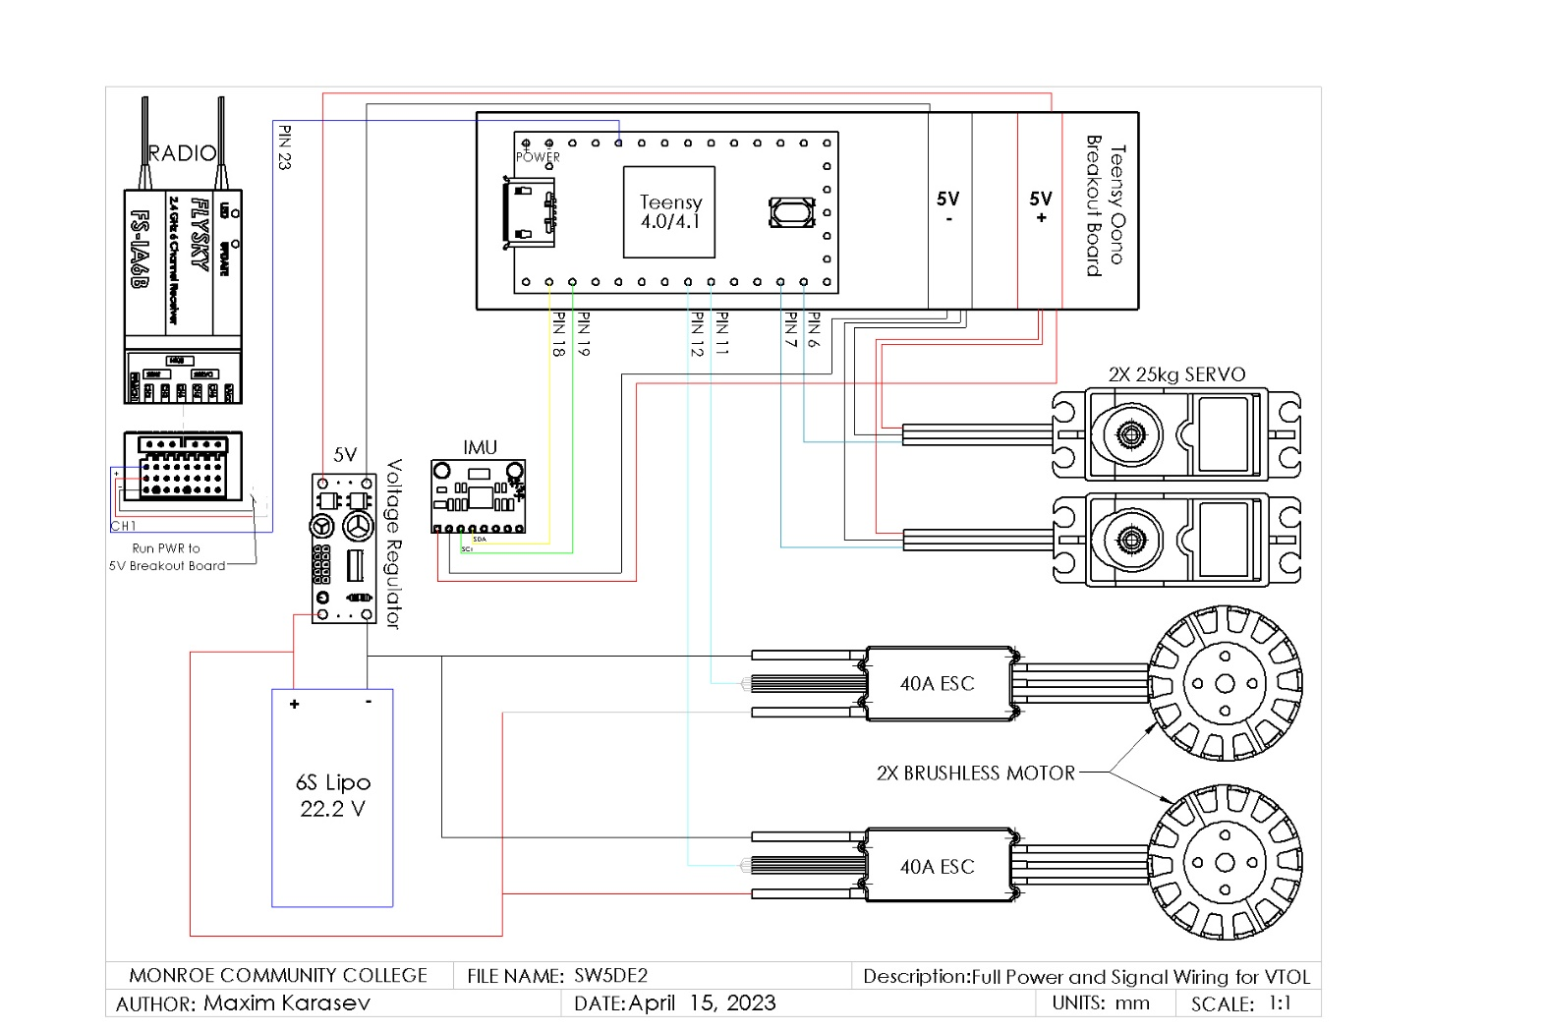

Figure 8: Circuit Diagram

The electronic circuitry of the project consists of a Teensy 4.0/4.1 microcontroller running the dRehmflight Arduino software developed by Nicholas Rehm. The Teensy serves as the flight controller unit for the project, handling various inputs and outputs.

The Teensy receives signals from two sources: an FS-I6B receiver and an MPU6050 IMU (Inertial Measurement Unit). The FS-I6B receiver is responsible for receiving remote control signals, allowing the user to control the drone. Since we are using PPM (Pulse Position Modulation) as our RX output we only need 1 wire for all 6 channels instead of an individual wire for each channel with SBUS (Serial BUS). The IMU captures motion data from various sensors such as accelerometers, gyroscopes, and magnetometers, providing information about the aircraft's orientation and movement.

The Teensy then processes these input signals and sends commands to several components. The electronic speed controllers (ESCs) receive signals from the Teensy, controlling the motors' speed and direction. This allows the aircraft to achieve controlled movement and adjust its thrust. Additionally, the Teensy sends signals to servos, which are responsible for tilting the motors. By adjusting the servos' positions, the aircraft's pitch and roll can be controlled, enhancing stability and maneuverability.

Figure 9: PPM Output

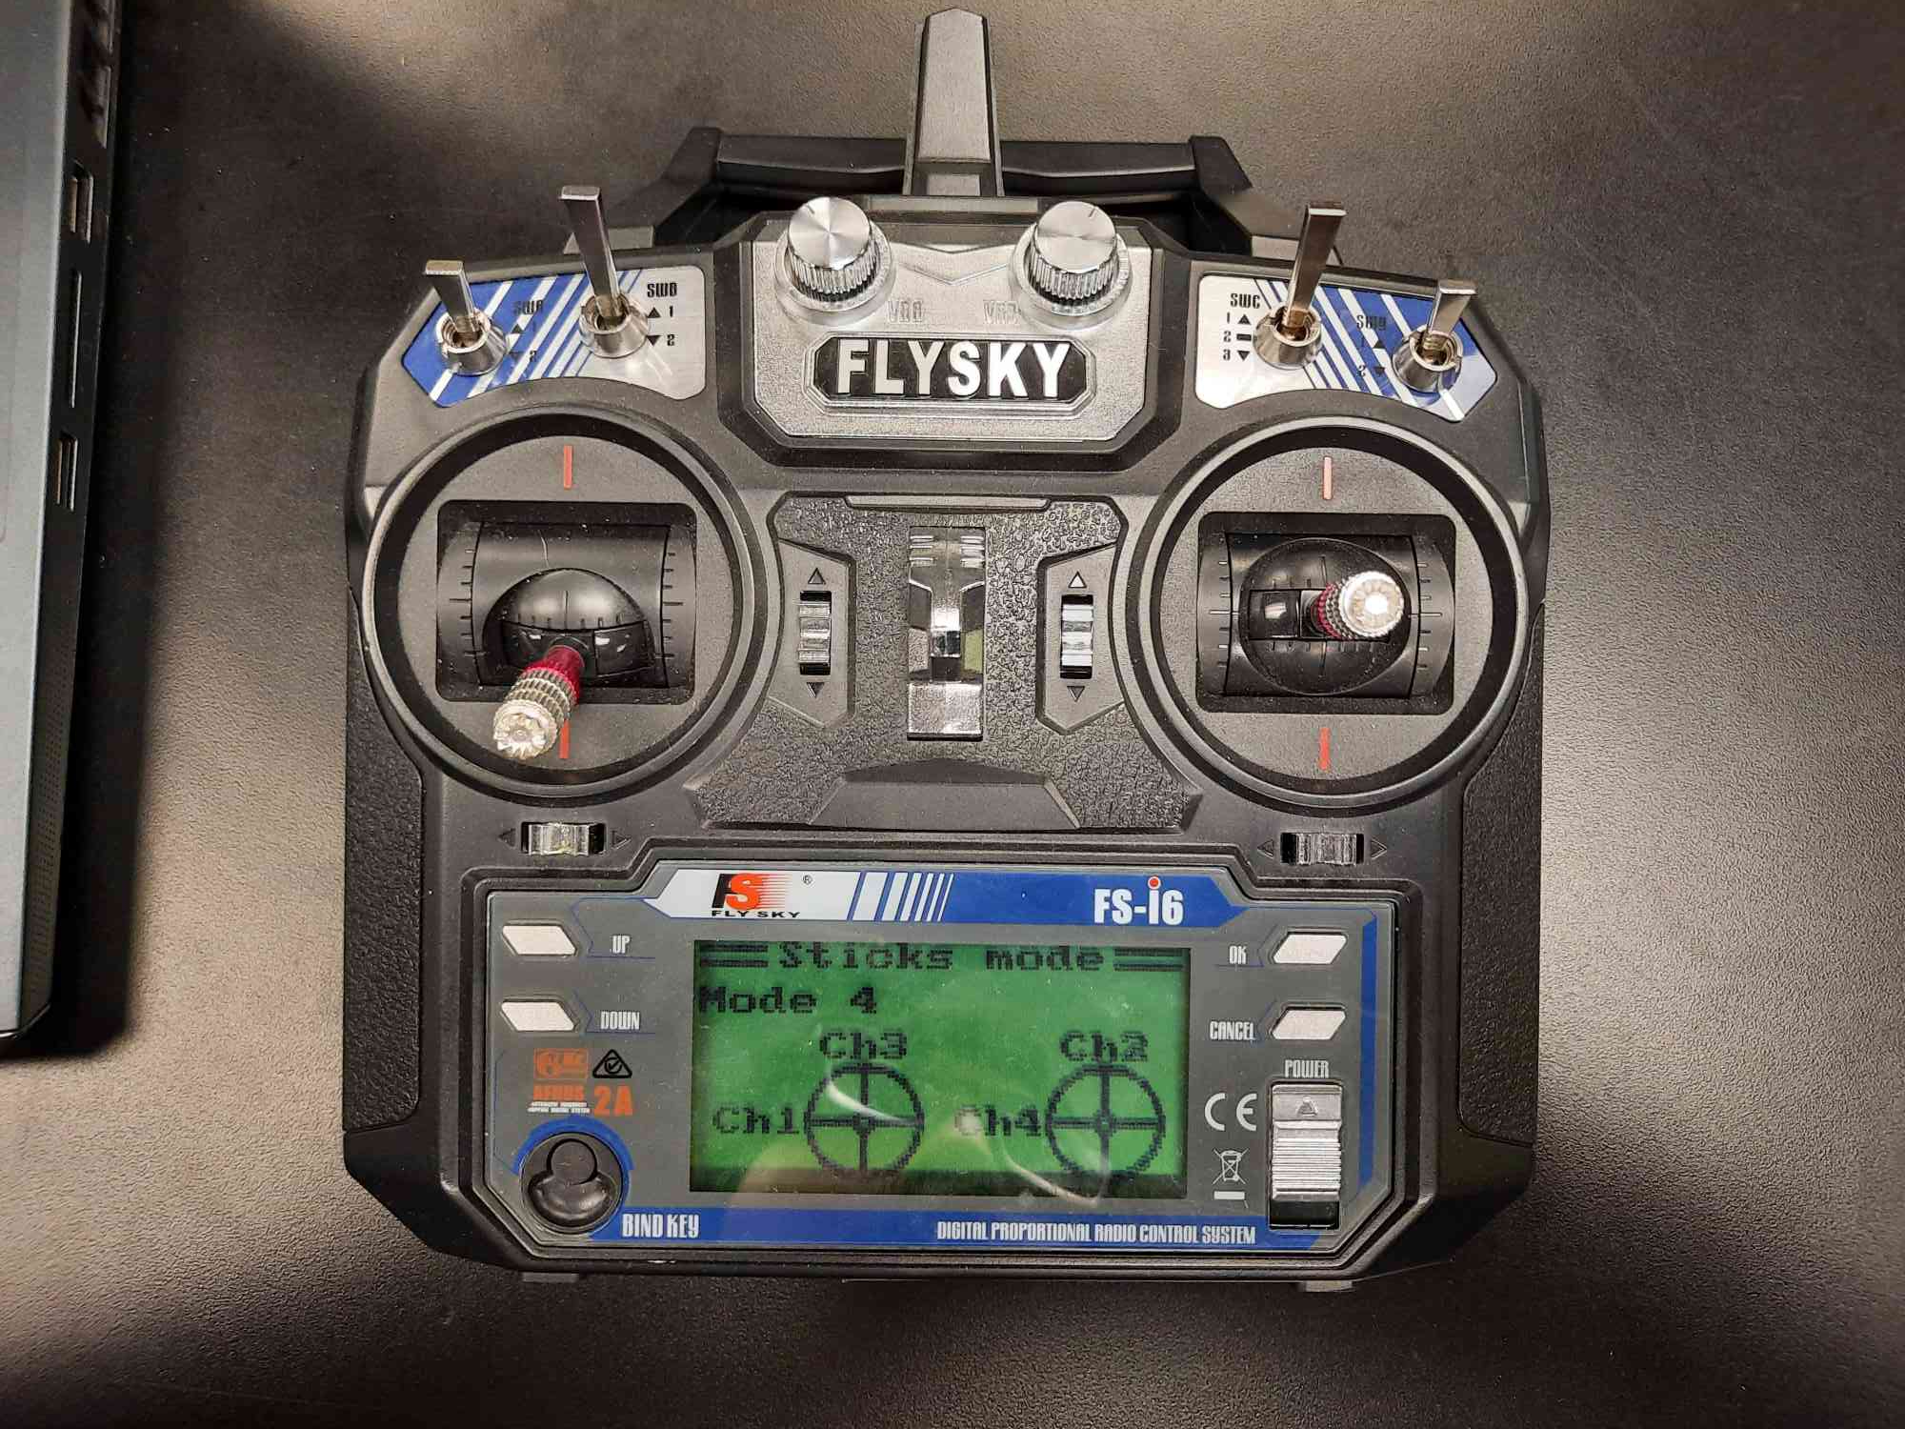

Figure 10: Sticks Mode

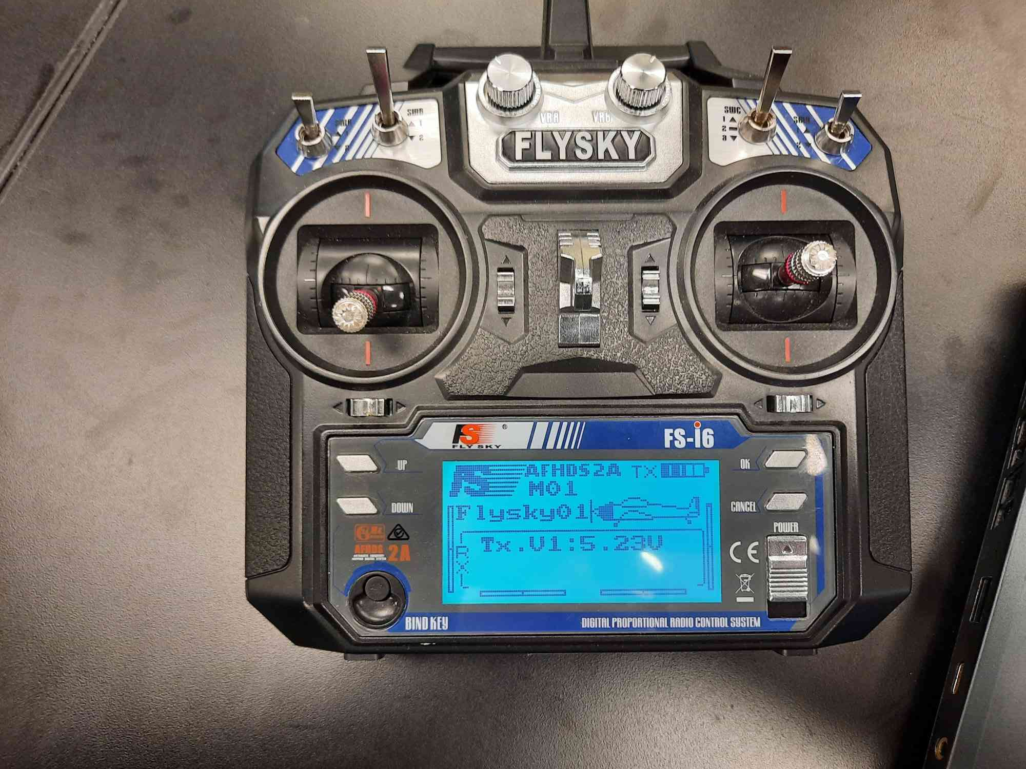

Figure 11: Trim (Red boxes are where the trim is visually indicated)

The transmitter has multiple settings that are important to note. To simplify the wiring on the drone, we are using PPM on the receiver, so we must make sure the transmitter is outputting the same way. So, on the transmitter PPM output must be activated as seen in figure 9. The next thing is the channels must correspond to what the channels are in the code, so under sticks mode we can change which channels are assigned to which stick. See figure 10. Channels 5 & 6 are auxiliary switches for mode switch and arm. Lastly while flying the drone, you can perform trim which tunes each channel. zero position. This allows you to re-zero the craft’s throttle, roll, pitch, and yaw axis of rotations. These are indicated in the transmitter’s main display as the vertical/horizontal bars which a slider in them. See figure 11.

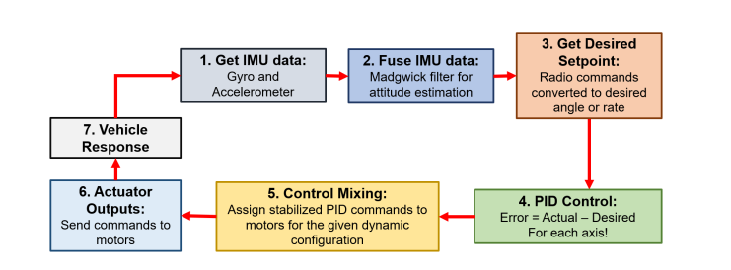

Figure 12: dRehmFlight control loop (Credit to Nicholas Rehm)

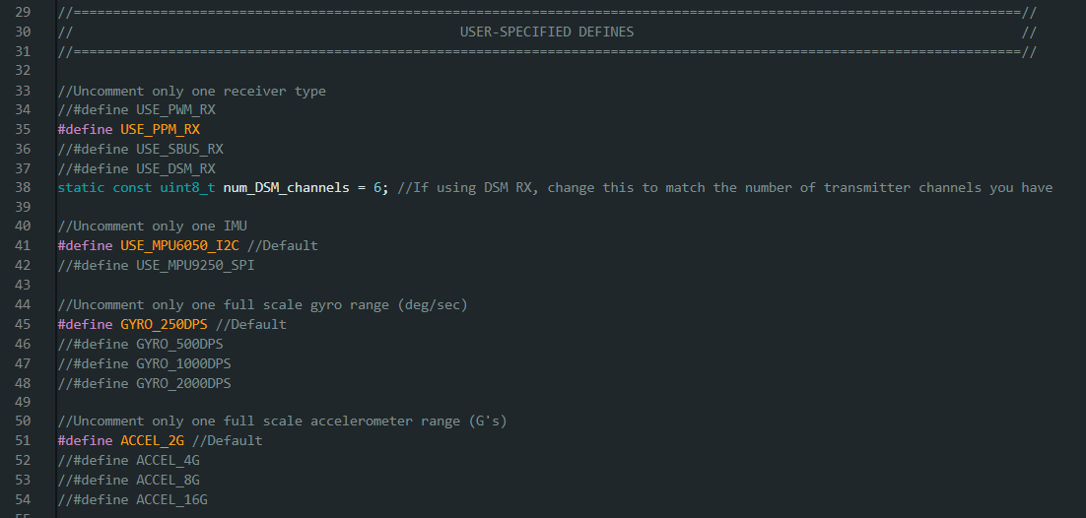

Figure 13: Hardware Declaration

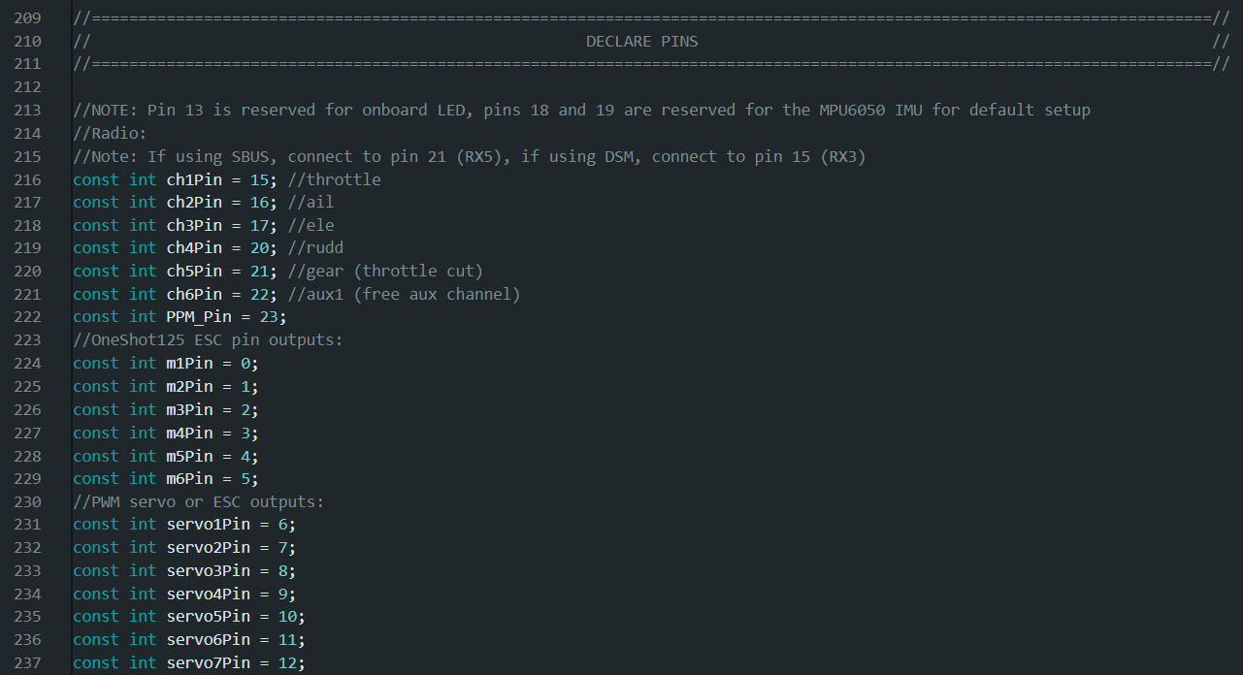

Figure 14: Pin Declarations

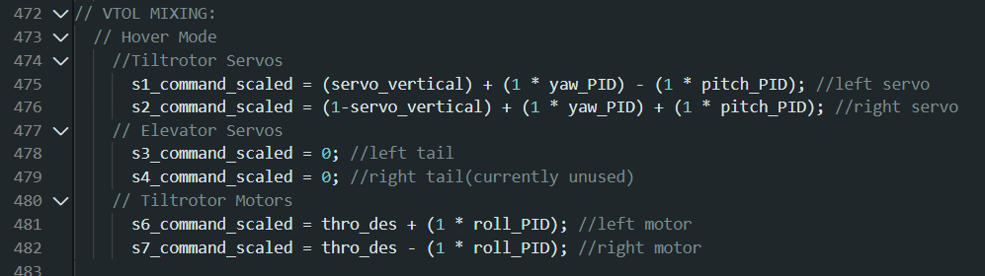\

Figure 15: Control Mixing

Figure 16: Throttle Cut Channel Assignment

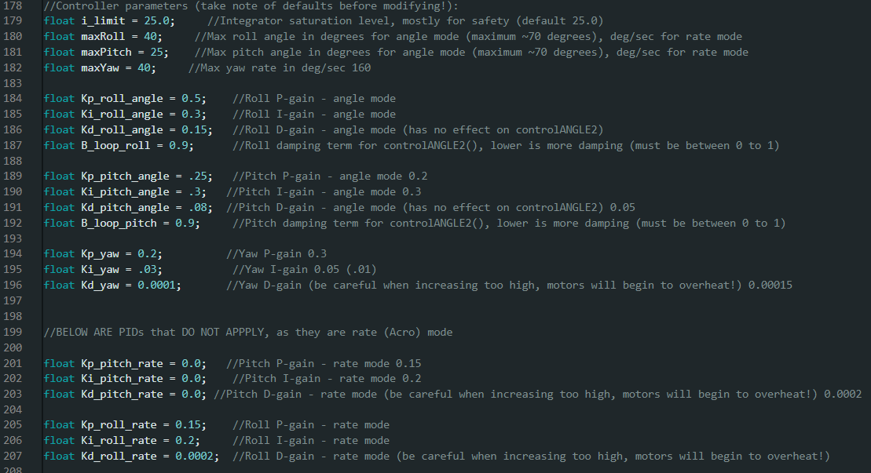

Figure 17: PID Tuning

The language we are using to code Teensy is Arduino. This language is versatile and has many packages available for almost any use case. A plug-in, Teensyduino created by Paul Stoffregen is used for USB serial connection to the Teensy.

The dRehmflight stabilization package created by Nicholas Rehm provides the framework for creating your own control mixing and tuning for manual flight and auto stabilization. The sections of the code that we edited were the radio, pin declarations, the control mixer function, and the PID values. These were changed in accordance with our specifications for the bi-copter tiltrotor design. The PID values were changed through experimentation. The experimentation involved having the craft held preventing takeoff however had enough degree of freedom to notice if it was drifting in the wrong direction. We did differential thrust (roll) first then yaw and finally pitch tuning in the gym and PAC center here on campus. Currently there is only a hover mode in the code. In the future we will be using Channel 6 switch to have a transition mode that flips between hover and forward flight. Channel 5 is a 2-mode switch which arms the motors giving us the most basic type of failsafe, a kill switch.

# 6. Fabrication Methods

Figure 18: Side Panel Drawings

Side panels which we 3D printed in PLA because we were not able to get our own machinists to make one in time.

Figure 19: Bottom plate that attaches side panels.

Figure 20: Base plates for the tilt-mechanism that was originally going to be machined but opted to 3D print in PLA for the prototype.

Figure 21: 3D Tilt-Mechanism Assembly

Figure 22: NACA 4412 Airfoil that was 3D printed in heat resistant light-weight PLA in the final.

***Figure 23: This attaches to the rear of the side panels to hold the rear carbon fiber rod as tail.***

Ender 5 Plus 3D Printer Method X 3D Printer

Figure 24: 3d Printers

We used the Ender 5 Plus to 3D print parts in PLA or lightweight PLA. Most of our designed parts were fabricated through PLA. We used the Method X for any part that needs to be printed in a stronger material which was Carbon Fiber Nylon. This allowed for any parts that have a lot of forces at play to be stable and reduce the chances of failure.

# 7. Design Analysis:

The design for the tiltrotors provides a reliable and stable way of controlling the thrust vectors of our motors. This allows us to perform stable flight and maintain hover through the stabilization code. Our first test flight was successful in getting off the ground but some more tuning was required as it was unstable in some axis’s. Due to the wind, we couldn’t properly adjust our transmitter trim so after the first flight we headed inside to the PAC center, an indoor field, to tune it further. This proved very useful as it allowed us to further finetune the PID values. This led to the drone being able to take off and the stabilization code kept it in place hovering.

From this stage we redesigned our landing gears as seen in figure 5, moved the battery to the nose and added wings to our carbon fiber rods. This was all done in preparation for the forward flight transition test. With all these redesigns we will need to redo our PID & trim tuning for the hover mode. The forward flight capabilities of this drone are still in progress as we design and prototype the tail section for pitch control in the forward flight. We will also have to add in the forward flight and 2-mode transition switch.

https://youtu.be/snkThKrBGW0

Figure 25: First Flight Video

Figure 26: Bill of Materials

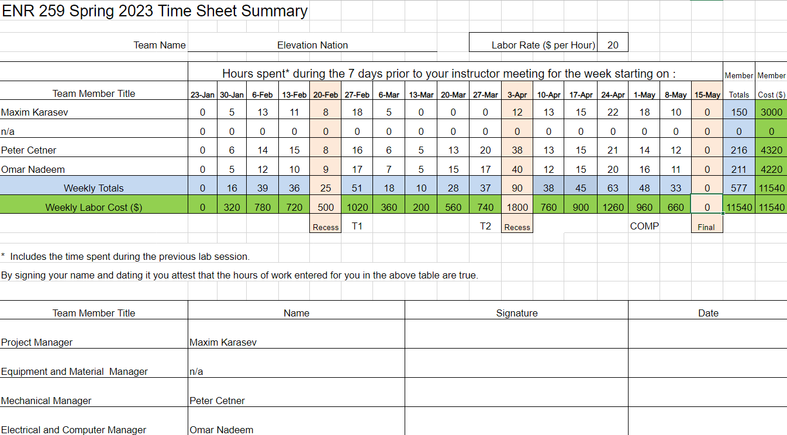

Figure 27: Time Sheet

# 8. Team and Technical Analysis

a. Team Functionality:

Throughout this project, our team functioned cohesively and effectively. We communicated clearly through a hybrid approach, using discord as well as in-person meetings. We assigned specific roles and responsibilities to each team member and maintained regular meetings to track progress and discuss challenges as they occurred. Collaboration and teamwork were strong, with each member actively contributing their skills to the project. Our work environment encouraged open discussions and idea sharing, which helped us have good brainstorming sessions and come up with good solutions to problems.

b. Problem Identification and Resolution:

While our team functioned well overall, no engineering project would be complete without a few hiccups along the way. One notable issue was the power distribution problem we ran into, where the current drawn from the motors caused a voltage drop at the teensy. To address this, we conducted thorough research, consulted technical resources, and experimented with different battery configurations until we found the problem, and then implemented an effective solution. Additionally, we faced difficulties with control mixing and PID tuning, leading to unstable flight characteristics. To rectify this, we dedicated time to studying PID control theory, fine-tuned the PID parameters, and conducted numerous flight tests to achieve stable flight performance.

c. Potential Team Structure Improvements:

If we were to repeat this project, we would consider adjusting the team structure to ensure a more even distribution of workload and specialization. While our current structure worked well, we believe a more rigidly defined division of tasks and responsibilities, tailored to each of our strengths and interests, would further optimize our productivity. Additionally, we feel that having more team members with varied disciplines would have been helpful. Having only three mechanical engineers made it very difficult to do any electrical and software work, as it was very slow and tedious.

d. Appropriateness of Components and Methods:

Our team carefully evaluated and selected components and methods that aligned with the requirements and objectives of the project. The decision to use additive manufacturing, specifically 3D printing, proved to be extraordinarily effective for rapid prototyping and iteration. We utilized off-the-shelf electronics, such as motors and ESCs, that were suitable for our project requirements and integrated well with our custom-designed components.

e. Effective Design Decisions and Challenges:

Several design decisions proved successful in achieving our goals. The redesign of the landing gear and battery mount using ABS 3D-printed parts significantly improved rigidity and durability, addressing the previous revision which used zip ties. The utilization of LW-HT-PLA material for the wing sections enhanced impact resistance without compromising weight. These design decisions contributed to the overall functionality and performance of the UAV. However, we encountered challenges with one of, leading to the decision to replace the motors and ESCs. While this incurred additional costs, it was a necessary step to ensure safety and reliability during the flight. Our initial intention was to use spare motors and ESCs to save costs, but in hindsight, we should have considered alternative motor options earlier in the design process.

f. Potential Design Choice Modifications:

If we were to repeat the project, which the MCC drone team essentially will be doing next year, we would refine our design choices based on the lessons learned during this iteration. Specifically, we start the design process by selecting motors, ESCs, and a power system, then designing an aircraft around that. Additionally, we would explore advanced motor control techniques to further optimize motor performance and efficiency. Furthermore, we would invest more time in aerodynamic analysis and optimization to improve the overall flight characteristics and efficiency of our UAV. By keeping in mind these potential changes, we believe our future design choices would result in an even more refined and efficient VTOL UAV, enhancing its capabilities and expanding its potential applications.